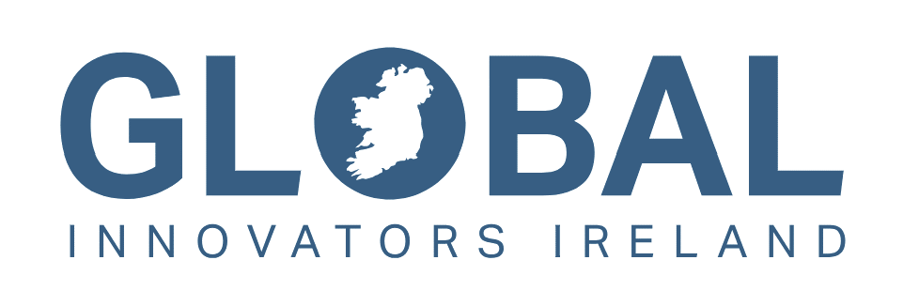

**Innovate for Ireland 2025 Programme**

*Expression of Interest*

|  |  |
| --- | --- |
| Name of Lead Applicant |  |
| Name(s) of Co-Applicant(s)* |  |
| Host Research Body (or Bodies)* |  |
| Proposed title (up to 30 words)* | |
|  | |
| Abstract (up to 200 words)* | |
|  | |
| Relevant Innovate for Ireland thematic area and alignment of the research programme with the thematic area (up to 200 words) | |
|  | |

*\*All of these details can be amended further at the full application stage.*

|  |
| --- |
| **Expressions of Interest must be submitted directly to** [**i4i@researchireland.ie**](mailto:i4i@researchireland.ie)**.**    **Deadline for EOI submissions:**  **Wednesday 19th February 2025 at 13:00 Dublin local time**    **EOI submission is mandatory for the Thematic Cohort stream and recommended for the Industry Partnership stream. Please ensure that you liaise with your local Research Office to make them aware that you will be submitting an application to the call.** |